**Define:**

Pointers C++: Variables whose value is the address of another variable.

Why are pointers useful in C++?

Pointers are good for managing memory especially for smaller devices where memory is more of a commodity.

Allows us to accomplish similar outcomes without sacrificing memory. The more available memory, the better the machine performs.

Pass by Value: The way it’s been done in this class until this point. The values are passed by being stored in the variables.

Pass by Reference:

Compare and contract pass by value and pass by reference-

**LAB ASSIGNMENT**

**Update your previous program from Assignment 12 to Pass values between functions by reference.**

**Create independent return functions that calculate each planetary body independently.**

**In main() create a menu that controls the program.**

**The program should bring receive input only in main() and pass values to other parts of the program.**

**Create a program that will calculate your weight on Mercury, Venus, Mars, and Earth’s moon.**

**Label the output so it is clear your weight on each independent planetary body.**

* **Update your program to prompt the user for input instead of assigning the values to variables.**
* **If the user input for weight is 0 or less than prompt the user “Input 0 or less than 0.**

**Attach a snipping photo of the source code and output**

**(You are welcome to use the IDE or the Notepad text editor.)**

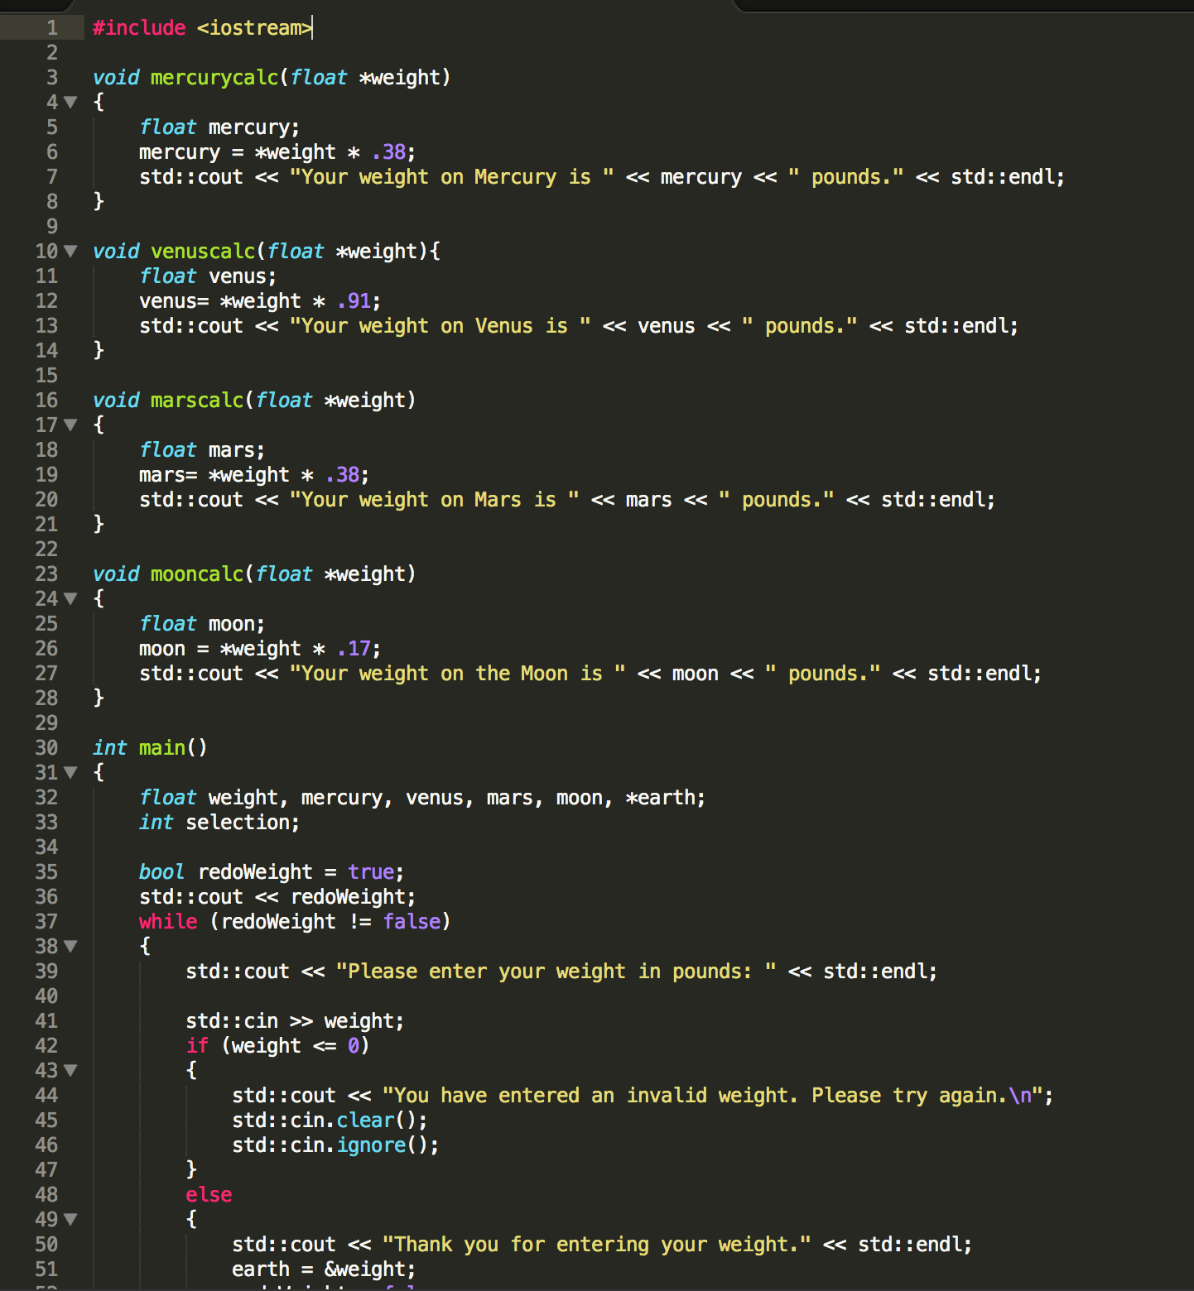

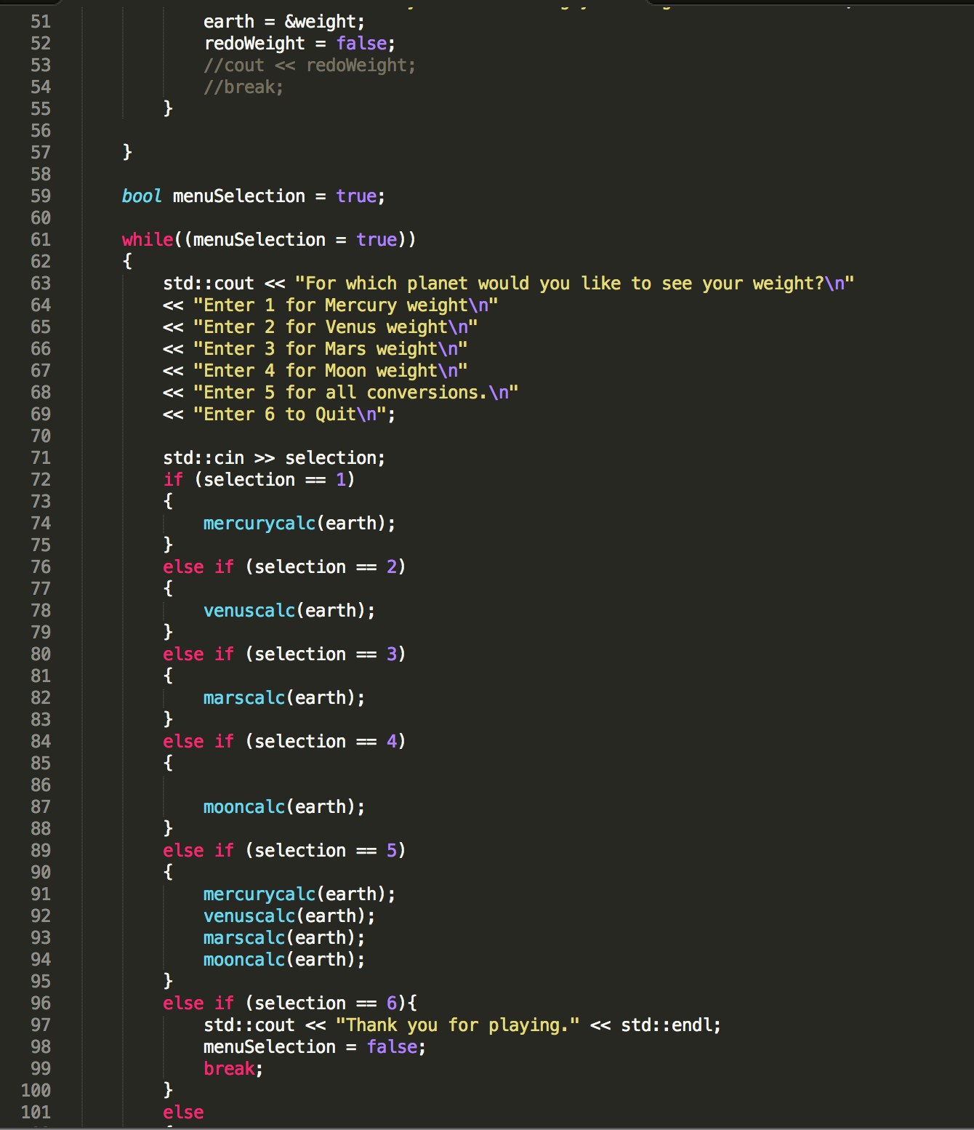

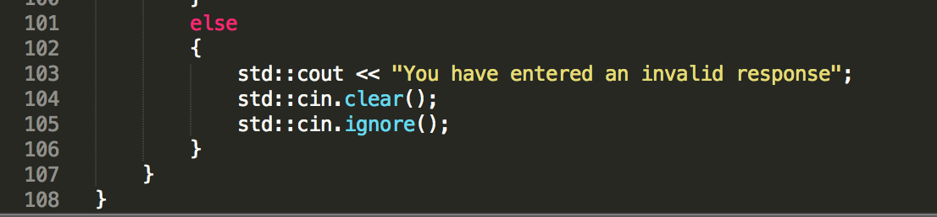

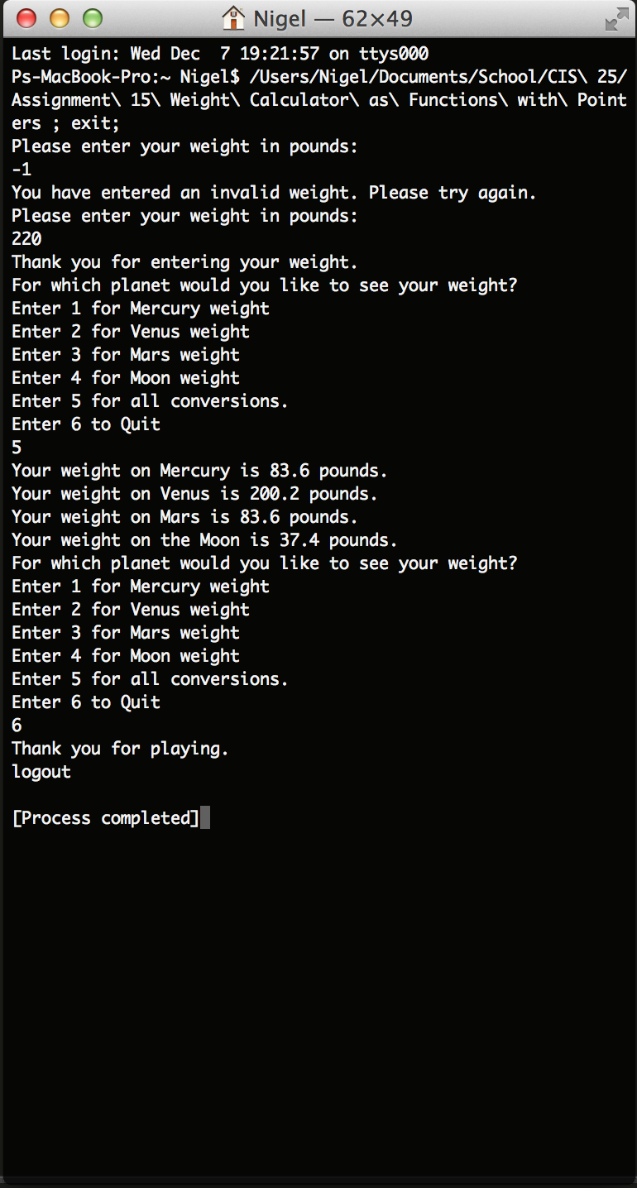

**LAB ASSIGNMENT**

**Update you assignment to pass values between functions by reference.**

**Interest Rate + Principal Calculator**

**Create a program that will that will calculate Yearly Interest or Compound Interest on a starting principal.**

**Accept user input in dollars$ in main(). Program should not run if dollar amount > 0. Prompt user and exit the program.)**

**Your program will have a menu.**

**\*\*\*\*\*\*\*\*\*\*\*\*\*\*\*\*\*\*\*\*\*\*\*\*\*\*\*\*\*\*\*\*\*\*\*\*\*\***

**\* Main Menu: \***

**\* Enter # to run program or Quit \***

**\* 1) Yearly Interest Calculator \***

**\* 2) Compound Interest Calculator \***

**\* 3) Quit \***

**\*\*\*\*\*\*\*\*\*\*\*\*\*\*\*\*\*\*\*\*\*\*\*\*\*\*\*\*\*\*\*\*\*\*\*\*\*\***

**Yearly Interest Function: Create a function that accepts 3 arguments.**

1 argument will represent **savings**

1 argument will represent **years.**

1 argument will represent **interest rate.**

**Function will output each year's principal value. (Output will not be one singular value, but each year’s value.) So if years == 10, there will be 10 outputs.**

**Compound Interest Function: Create a function that accepts 4 arguments. (Research on compound interest is required.)**

1 argument will represent **savings**

1 argument will represent **years**

1 argument will represent **interest rate.**

1 argument will represent **number of times it is compounded.**

